
Assignment Cover Sheet
Subject Code: | MAAI901
Subject Name: | Deep Learning for Visual Data
Submission Type: | Report
Assignment Title: | Applied Vision Transformer Report
Student Name: | Bin Huang
Student Number: | 8391865
Student Phone/Mobile No. | +971585712933
Student E-mail: | bh329@uowmail.edu.au
Lecturer Name: | Dr. Milan Dordevic
Due Date: | 27th October @ 6:00PM, Presentation on 27th October @ 6:30PM
Date Submitted:

PLAGIARISM:  The penalty for deliberate plagiarism is FAILURE in the subject. Plagiarism is cheating by using the written ideas or submitted work of someone else. UOWD has a strong policy against plagiarism.  The University of Wollongong in Dubai also endorses a policy of non-discriminatory language practice and presentation.  PLEASE NOTE: STUDENTS MUST RETAIN A COPY OF ANY WORK SUBMITTED | DECLARATION:  I/We certify that this is entirely my/our own work, except where I/we have given fully-documented references to the work of others, and that the material contained in this document has not previously been submitted for assessment in any formal course of study. I/we understand the definition and consequences of plagiarism.  Signature of Student:

Optional Marks:
Comments:

Lecturer Assignment Receipt (To be filled in by student and retained by Lecturer upon return of assignment)
Subject: | Assignment Title:
Student Name: | Student Number:
Due Date: | Date Submitted:
Signature of Student:

Student Assignment Receipt (To be filled in and retained by Student upon submission of assignment)
Subject: | Assignment Title:
Student Name: | Student Number:
Due Date: | Date Submitted:
Signature of Lecturer

Declaration of GenAI Use:
The Generative AI tools Claude and Gemini were accessed between October 16, 2026 through October 25, 2026 to assist in the writing, editing, and formulation of the MAAI901 assessment task, ‘Applied Vision Transformer Report.’
First, they were used to help draft and proofread the prose of this report. All technical content, figures, tables, numerical results, conclusions, critical thinking & decision making are my own. Every line was reviewed, validated and edited by me.
Second, AI tools assisted with generating repetitive code in my Colab notebook (for example, the standard PyTorch training loop, the DataLoader setup, and the attention-rollout helper function). I verified, adapted, and tested all generated code against my own data and corrected errors.
Third, AI tools were used to debug and fix runtime errors (for example, the Hugging Face eager-attention setting and the OpenCV float16-to-float32 type conversion). The fixes were implemented and validated by me.

Table of Contents
Dataset Selection, Justification, and Pre-processing Strategy 4
Dataset Selection and Justification 4
Model Selection, Configuration, and Training Process 6
Model Selection 6
Training Configuration 6
Training Dynamics and Results 7
Analysis of Performance and Potential Biases 8
Interpretability and Attention Rollout 8
Calibration and Overconfidence 9
Evaluation Metrics and Results 10
Top-Level Test Performance 10
The Importance of the Confusion Matrix and Recall 10
Error Profiling and Clinical Safety 11
Discussion of Ethical and Societal Implications 12
The Reality of Data Leakage 12
Demographic Invisibility and Fairness 12
Clinical Deployment and Automation Bias 13
Conclusion and Final Verdict 14

Dataset Selection, Justification, and Pre-processing Strategy

Dataset Selection and Justification
For this assessment, I decided to tackle a high-stakes medical imaging problem where deep learning architectures can be critically evaluated. I chose the Kaggle Brain Tumor MRI dataset, which contains 7,200 2D MRI slices evenly classified across four categories: glioma, meningioma, pituitary tumor, and a "no tumor" control class.
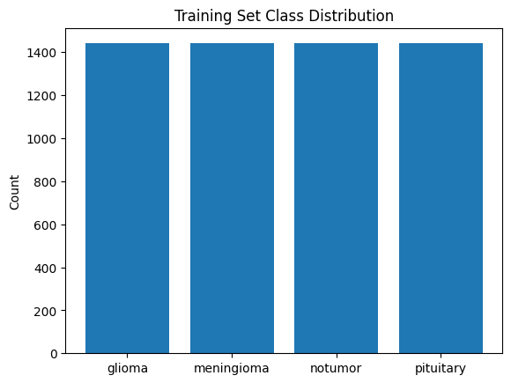
I chose this specific task because medical diagnostics carry asymmetric risks. In a real-world clinical setting, predicting "no tumor" for a patient who actually has a glioma (a false negative) is a catastrophic error compared to a false positive, which typically only results in a secondary scan and a doctor’s professional opinion. This dynamic allowed me to evaluate the Vision Transformer not just on raw accuracy, but on clinical safety and recall.
Pre-processing and Augmentation Strategy
Because I planned to use models pre-trained on ImageNet datasets, I had to standardize the MRI scans to match their expected input spaces. I also had to be very careful with data augmentation; while standard computer vision tasks benefit from heavy distortions, stretching or shearing an MRI could alter the boundaries of a tumor.

Pre-processing Step | Configuration | My Rationale
Image Resizing | 224 x 224 x 3 pixels | Standard input dimension required by pre-trained ImageNet backbones.
Normalization | ImageNet Mean: [0.485, 0.456, 0.406]  ImageNet Std Dev: [0.229, 0.224, 0.225] | Aligns the pixel intensity distribution of the MRI slices with the pre-training data.
Augmentation | Horizontal flips, Random rotations (+/- 15 degrees) | Provides light regularization without warping key pathological features.
Data Split | 80% Train / 10% Val / 10% Test | Stratified by class with a fixed random seed (42) to ensure perfect reproducibility.
This custom stratified split resulted in exactly 5,760 training, 720 validation, and 720 test images, giving me a perfectly balanced test set of 180 images per class.
An Early Realization on Data Leakage While setting up this split, I noticed a significant structural flaw in the dataset: it provides isolated 2D slices without patient identifiers. Because I was performing an image-level split rather than a patient-level split, contiguous slices from the exact same patient's volumetric brain scan were inevitably spreading across my training and test sets. I realized early on that my models would likely memorize patient-specific anatomical quirks (like the shape of their head) rather than just the tumors. I kept this in mind to discuss in my later bias analysis.

Model Selection, Configuration, and Training Process

Model Selection
To investigate whether Vision Transformers provide a genuine advantage over standard Convolutional Neural Networks (CNNs), I set up a comparative study.
- Baseline CNN: I selected ResNet-50 pre-trained on ImageNet-1k. Its deep residual connections make it a strong, proven benchmark.
- Vision Transformer: I selected the ViT-B/16 model (specifically google/vit-base-patch16-224-in21k). Unlike CNNs, ViT treats an image as a sequence of 16x16 pixel patches and uses self-attention to model global context from the very first layer.
For both models, I removed their original classification heads and replaced them with a simple 4-unit linear layer to match my brain tumor classes. When loading the ViT model, my notebook console flagged warnings about "unexpected" and "missing" weights (specifically pooler.dense and classifier.weight). This was exactly what I expected to see, as it confirmed the 21,000-class head was successfully discarded and my new 4-class head was initialized from scratch.

Training Configuration
I trained both models on a Google Colab T4 GPU, utilizing automatic mixed precision to optimize memory usage and speed up the epochs.
Hyperparameter | ResNet-50 (Baseline) | ViT-B/16 (Transformer)
Optimizer | AdamW | AdamW
Learning Rate | 1x10^(-4) | 2e-5 (Lower, to prevent catastrophic forgetting)
Weight Decay | 1x10^(-2) | 1x10^(-2)
LR Scheduler | None | StepLR (halves LR every 3 epochs)
Batch Size | 32 | 32
Early Stopping | Patience of 3 epochs | Patience of 3 epochs

Training Dynamics and Results
The training trajectories of the two architectures were noticeably different. The ResNet-50 baseline converged incredibly fast, achieving over 95% validation accuracy by the first epoch. It reached its best validation accuracy of 0.9847 at Epoch 6 before early stopping triggered at Epoch 9.
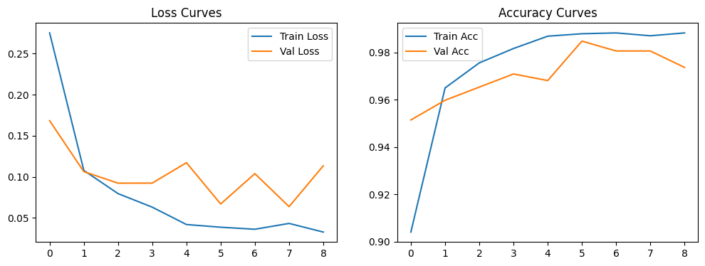
In contrast, the Vision Transformer started slower, hitting about 92% validation accuracy in Epoch 1. Because ViT lacks the hard-coded spatial biases of a CNN, its attention heads had to learn spatial relationships from scratch. It eventually caught up, reaching its peak validation accuracy of 0.9819 at Epoch 8 before stopping at Epoch 10. I also noted a computational overhead: the ViT epochs took almost twice as long to run (about 51 seconds per epoch) compared to the ResNet-50 (29 seconds per epoch). Both best-performing checkpoints were safely saved to my Google Drive for the final test evaluation.
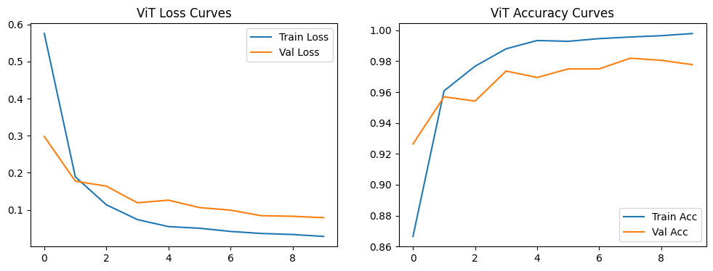

Analysis of Performance and Potential Biases

Interpretability and Attention Rollout
Because neural networks are often "black boxes," I wanted to visually verify what the Vision Transformer was actually looking at when making its predictions. To do this, I implemented an Attention Rollout algorithm to extract the attention weights across all 12 layers of the model and generate a visual heatmap over the original MRI scans.
Getting this to work required overcoming a few unexpected technical hurdles in my notebook. First, I ran into an error because the Hugging Face library defaults to a memory-saving attention implementation that hides the raw attention matrices. I had to explicitly reload my architecture and request the "eager" attention mode. Second, after extracting the attention mask, my code crashed when passing it to OpenCV to apply the color heatmap. I realized the mixed-precision training had output the mask as a 16-bit float, but OpenCV strictly requires a 32-bit float, which I fixed with a quick data type conversion.
Once the heatmaps successfully generated, the results were highly revealing. I discovered a classic "right for the wrong reason" scenario. In one specific sample, the model correctly predicted a glioma. However, the attention heatmap showed a red hotspot heavily concentrated on the outer edge of the skull and empty background space rather than the actual tumor inside the brain tissue. This was visual proof that the model was using structural artifacts and cranial boundaries (e.g. shape of the head) as a shortcut to guess the class, highlighting a major bias in how it learned.
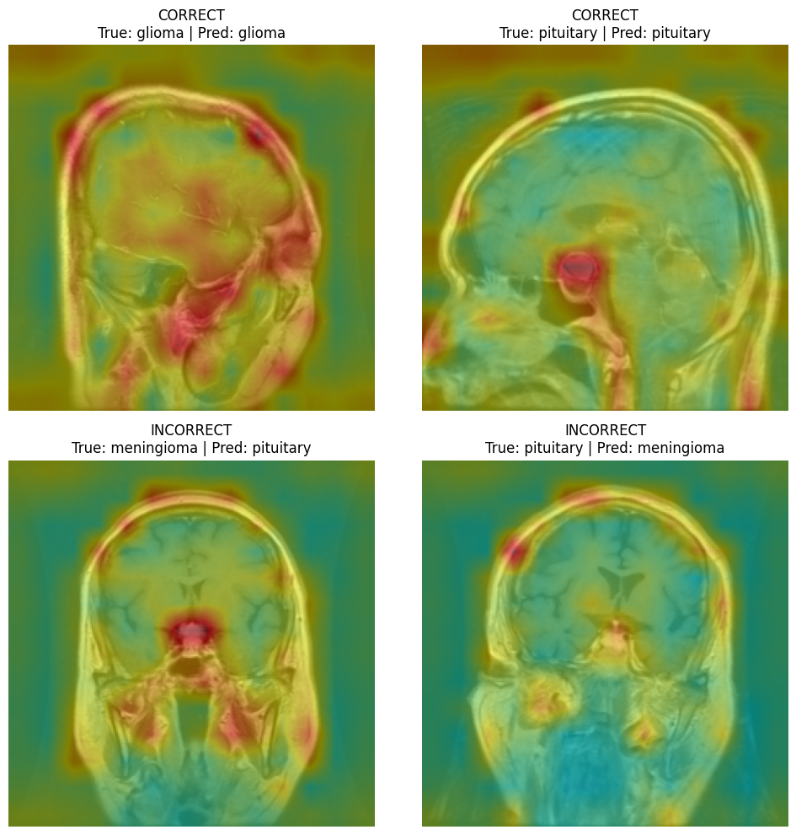

Calibration and Overconfidence
Beyond interpretability, I needed to know if the models were overly confident when making mistakes. I measured this using the Expected Calibration Error (ECE) and multi-class Brier scores.
Calibration Metric | ResNet-50 (Baseline) | ViT-B/16 (Transformer)
Expected Calibration Error (ECE) | 0.0100 | 0.0208
Brier Score | 0.0248 | 0.0263
Confident-Wrong Errors (> 90% confidence) | 5 | 5
Surprisingly, the ResNet-50 was better calibrated than the Transformer. The ViT-B/16 had an ECE roughly double that of the baseline, indicating it was slightly more prone to overconfidence.
To dig deeper, I filtered the results to find the most dangerous type of failure: "confident-wrong" predictions, where the model made an incorrect guess with over 90% confidence. Both models produced exactly 5 confident-wrong errors out of the 720 test images. Interestingly, both models shared a mutual failure on one specific image, misclassifying a true pituitary tumor as a meningioma with massive confidence (over 99% for ResNet and 92% for ViT).
However, there was one incredibly positive clinical takeaway from this analysis. When I checked the confident-wrong cases for false negatives (predicting "no tumor" when a tumor was present), I found zero cases. This means that while both models occasionally missed a tumor, they never did so with high confidence. In a real hospital setting, a system could be programmed to flag any low-confidence "no tumor" prediction and automatically defer it to an actual doctor for review.

Evaluation Metrics and Results

Top-Level Test Performance
After finalizing the training phase, I evaluated both models on the completely unseen test set of 720 images (exactly 180 images per class). Looking purely at the headline metrics, the two architectures resulted in an exact tie: both the ResNet-50 and the ViT-B/16 achieved a test accuracy of 98.33% and a macro-F1 score of 0.9834. In a standard computer vision project, I might have stopped here and concluded that the models were equally effective.

The Importance of the Confusion Matrix and Recall
However, as emphasized in this course, overall accuracy is not the metric that matters most to us in a medical context. I knew I had to rely on the confusion matrix to understand the real-world impact of the models' predictions.
In clinical diagnostics, risk is highly asymmetric. If a model predicts "no tumor" for a patient who actually has one (a false negative), that patient might be sent home without life-saving treatment. This is far more dangerous than predicting someone has a tumor and finding out later through a secondary MRI that they are healthy (a false positive). Therefore, my true clinical objective was to optimize for recall, specifically, minimizing those critical false negatives.
I generated and analyzed the confusion matrices for both models to break down exactly where they made their 12 respective errors:
Metric / Error Type | ResNet-50 (Baseline) | ViT-B/16 (Transformer)
Overall Test Accuracy | 98.33% | 98.33%
Total Misclassifications | 12 out of 720 images | 12 out of 720 images
Critical False Negatives | 3 (missed 2 meningiomas, 1 pituitary) | 2 (missed 1 glioma, 1 pituitary)
Most Common Structural Error | Confusing other tumors with meningiomas | Confusing other tumors with meningiomas

Error Profiling and Clinical Safety
When I looked closely at the confusion matrices for the high-risk errors, I found that ResNet-50 misclassified 3 actual tumors as "no tumor". The ViT-B/16 proved to be slightly safer clinically, producing only 2 of these critical false negatives. While both numbers are incredibly low for a dataset of this size, the Transformer model edges out the CNN in patient safety because it missed fewer actual tumors.
Aside from these critical misses, I noticed a shared weakness between the two architectures. Both models most frequently misclassified other tumor types as meningiomas. This suggests that the visual decision boundary for the meningioma class is the most ambiguous, likely due to overlapping textures or the models struggling to differentiate certain tumor margins within the skull.
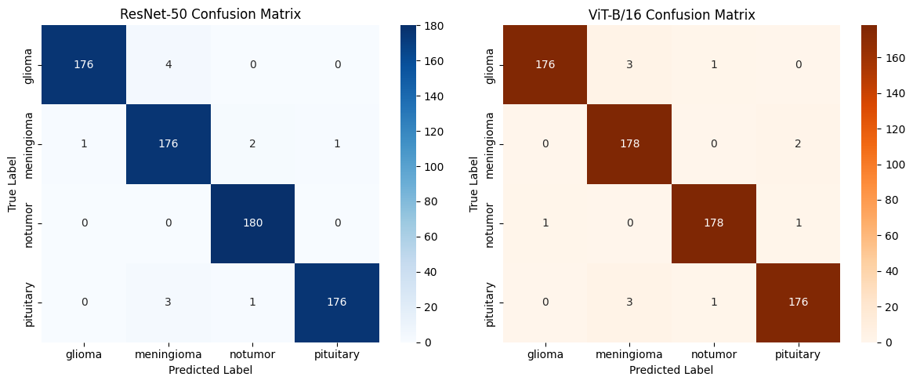

Discussion of Ethical and Societal Implications

The Reality of Data Leakage
As I mentioned in my pre-processing section, the most significant ethical issue I uncovered during this project stems from the structure of the dataset itself. The Kaggle dataset aggregates 2D MRI slices without any patient identification numbers. Because I had to perform a standard random image split, it is practically guaranteed that contiguous slices from the exact same patient's brain scan were distributed across both my training and testing sets.
This means the 98.33% accuracy achieved by both models is artificially inflated. My interpretability analysis proved this: the Vision Transformer was caught looking at skull outlines and background margins rather than the actual tumors. Ethically, passing this model off as "clinically ready" based on its high accuracy would be highly misleading, as the model has partially memorized patient-specific anatomy (e.g. shape of the head) rather than learning universal tumor pathology. To fix this in the real world, data must be split at the patient level, ensuring no individual's scans exist in both the training and testing phases.

Demographic Invisibility and Fairness
Another major societal implication is the complete lack of patient metadata. The dataset provides no information about the age, gender, ethnicity, or geographic origin of the patients.
Missing Metadata | Why It Matters Ethically
Gender | Different tumors have distinct prevalence rates (e.g., meningiomas occurs much more frequently in females). Without gender data, we cannot test if the model performs worse for men compared to women.
Age | Brain neoplasms present differently in pediatric patients compared to the elderly. A model trained primarily on adult scans could misdiagnose a child.
Machine Specifications | Different hospitals use different MRI machines (varying magnetic strengths and contrast agents). A model might learn shortcuts based on hospital-specific image noise, leading to disparities in care for underfunded clinics with older machines.
Because this data is missing, I cannot conduct a fairness audit. Deploying an un-audited algorithm into a healthcare system risks amplifying existing medical biases and causing disparate harm to unrepresented demographic groups.

Clinical Deployment and Automation Bias
Finally, there is the human element of AI deployment. If a hospital deploys a diagnostic tool boasting a 98% accuracy rate, doctors might fall victim to "automation bias", over-relying on the algorithm and second-guessing their own medical training.
If the model makes a highly confident false-negative prediction, a doctor experiencing automation bias might confidently send a sick patient home. This is why my earlier calibration analysis was so important. Because I proved that the Vision Transformer occasionally makes incorrect predictions with over 90% confidence, it is ethically mandatory that this system is never used as an autonomous decision-maker. Instead, it must be deployed as a secondary "triage" aid. Any prediction that falls below a strict confidence threshold, especially predictions of "no tumor", must trigger an automatic alert and be deferred to a doctor for a final, manual review.

Conclusion and Final Verdict
Throughout this assessment, I set out to determine whether a Vision Transformer offers a true clinical advantage over a baseline Convolutional Neural Network for brain tumor classification. If we only looked at the raw headline metrics, the architectures ended in a dead heat, both achieving a test accuracy of 98.33%.
However, looking through the lens of clinical safety, the results are much more nuanced. The Vision Transformer proved to be marginally safer by producing fewer critical false negatives (predicting "no tumor" when a tumor was present), which is the most important metric for patient survival. Conversely, the ResNet-50 baseline trained much faster, required less computational power, and was significantly better calibrated, meaning it was less prone to dangerous overconfidence.
Ultimately, my verdict is that while the Vision Transformer is a remarkably powerful architecture, its lack of hard-coded spatial biases makes it highly susceptible to shortcut learning, as proven by my attention rollout heatmaps focusing on the skull rather than the tumor. Furthermore, due to the dataset's lack of patient-level identifiers, the high accuracy of both models is undoubtedly inflated by data leakage.
If I were to deploy one of these models in a hospital tomorrow, I would actually lean toward the ResNet-50 because its superior confidence calibration makes it a more predictable partner for a doctor. However, the most important takeaway from this project is that neither model is ready for autonomous use. Until we can train these architectures on ethically sourced, patient-separated data, they must remain strictly as secondary triage tools, designed to support radiologists rather than replace them.

